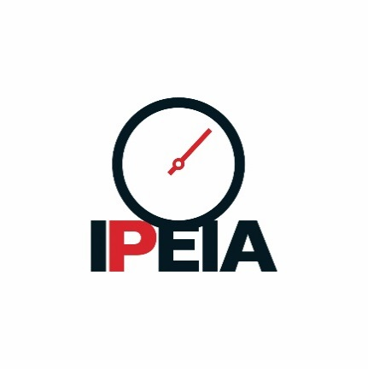

Integrity Challenge Forum

2023 Joint Technical Event Report

In March and April 2023 IPEIA in conjunction with several technical societies hosted joint events aimed at raising awareness of career opportunities in the Inspection and Examination industries. The well attended events were held in Edmonton and Calgary. Both events were moderated by Taber Hole and featured panel discussions along with questions from participants.

**2023-Mar-15 – Edmonton Joint Society Event**

**Careers in Examinations and Inspections: Tech Demo & Panel Discussion**

On March 15, a joint technical dinner event was held in Edmonton to help raise awareness of careers in the inspection and examination industry, both in terms of opportunities and challenges for the industry.  The event was co-hosted by IPEIA, the Alberta Section of the AWS, the Edmonton Section of AMPP, the Edmonton Section of ASM, and the Canadian Centre for Welding and Joining of the University of Alberta (CCWJ) – the event was located on the 8th floor of the Donadeo building at the University of Alberta.  The evening started with technical demonstrations, followed by dinner, and then wrapped up with a panel discussion.  The panelists included:

* Neal Mills – Confederacy of Treaty No. 6 First Nations
* Jennifer Dowdle – Acuren
* Josh Wierenga – Tourmaline
* Brian Beesley – IRISNDT

Additionally, Ryan Brosda (Acuren), Jolene Borrelli (Acuren), and Paul Toews (Tourmaline) provided additional support during the technical demonstrations.  The event was well attended, with more than 80 attendees, including nearly 40 students.  Technical demonstrations demonstrated a range of cutting-edge technology, and the panel discussion was well-received.

Brian Beesley, Neal Mills, Josh Wierenga and Jennifer Dowdle

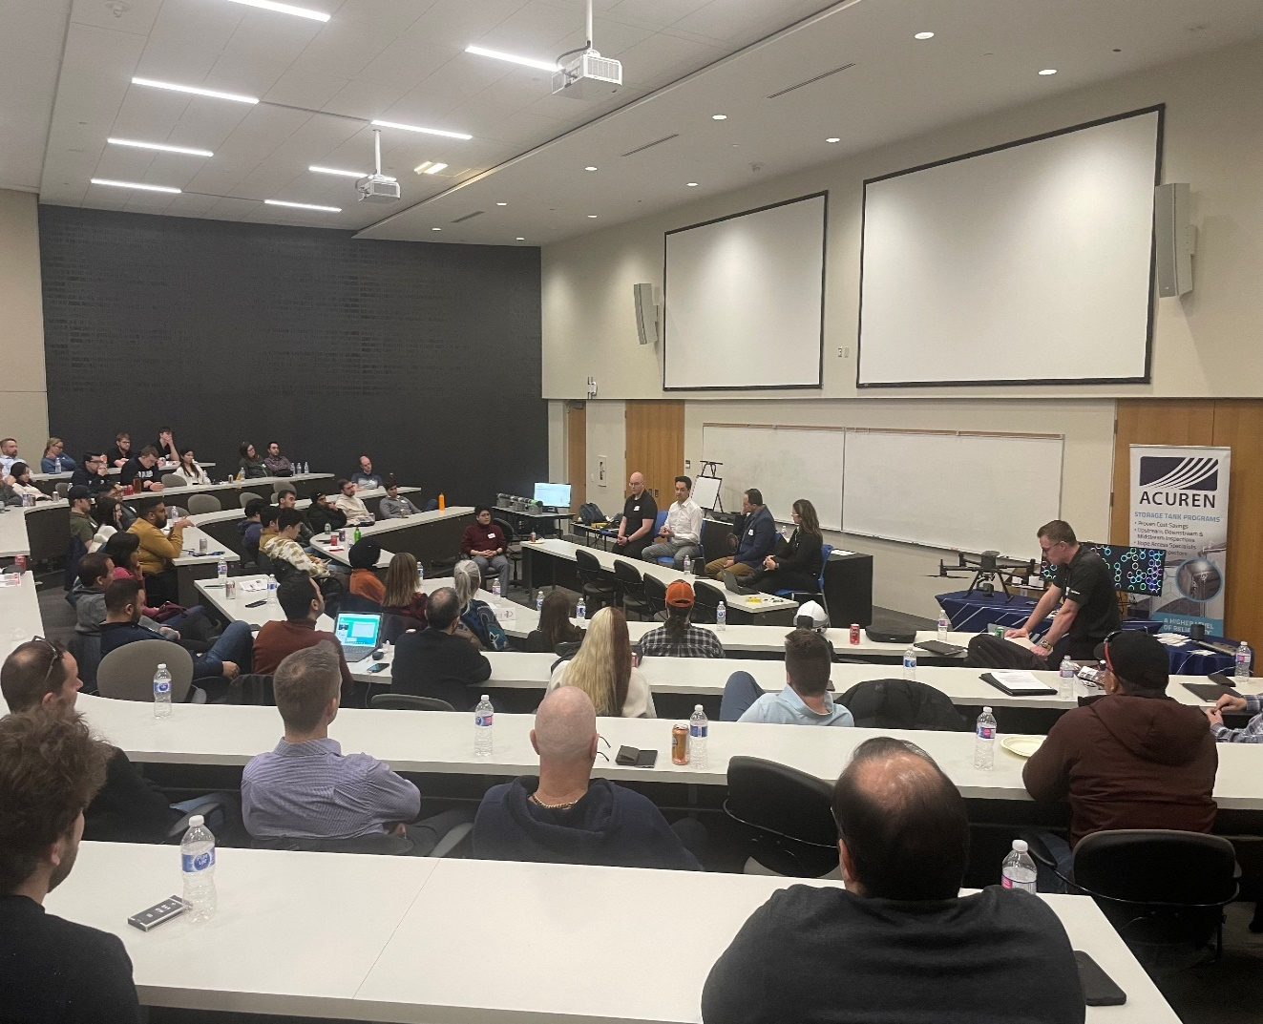

Donadeo Innovation Centre for Engineering University of Alberta

**2023-Apr-06 – Calgary Joint Society Event**

**The Next Generation Examiners and Inspectors**

On April 6, a joint technical dinner event was held in Calgary to help raise awareness of careers in the inspection and examination industry (both in terms of opportunities and challenges for the industry).  The event was co-hosted by IPEIA, the Alberta Section of the AWS, the Calgary Section of AMPP, the Calgary Section of CWB Group, Careers the Next Generation, and SAIT – the event was in Macdonald Hall at SAIT.  The evening included two panel discussions, as well as light refreshments.

The first panel focused on the student perspective of the industry, and the panelists included:

* Jeremiah Shirley - Teacher Counselor (Forest Lawn High School, Calgary Board of Education)
* Kelly Sidebottom - Welding / Fabrication Teacher (Forest Lawn High School, Calgary Board of Education)
* Armin Neuhofer – Student (SAIT, NDE Program)

The second panel focused on connecting potential workers with potential employers, and the panelists included:

* Gordon King - Program Development Specialist (Careers the Next Generation)
* Bob Khan - Director of Operations (Calgary Catholic Immigration Society)
* Rozlynn (Roz) Wick - Manager for Strategic Youth Initiatives (SAIT)
* Charles Lasouski – Recruiter & Organizer (Quality Control Council of Canada)

The event was well attended, with more than 40 attendees, nearly half of them being students.

Jeremiah Shirley, Kelly Sidebottom and Armin Neuhofer

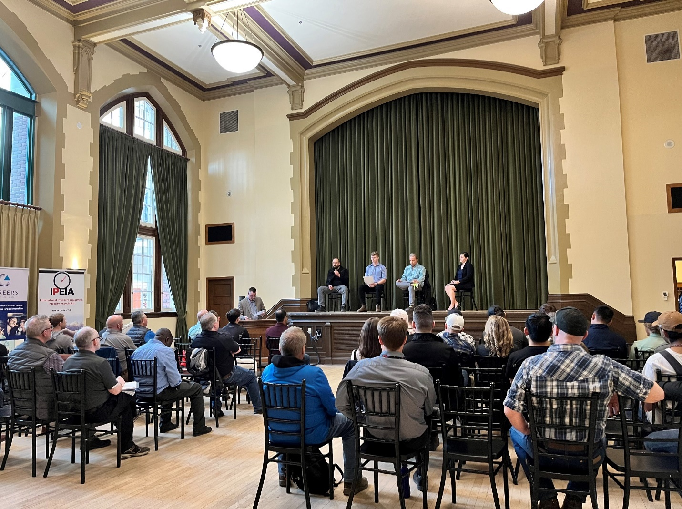

Bob Khan, Gordon King, Charles Lasouski and Rozlynn Wick

Macdonald Hall SAIT